Independent Board Directors 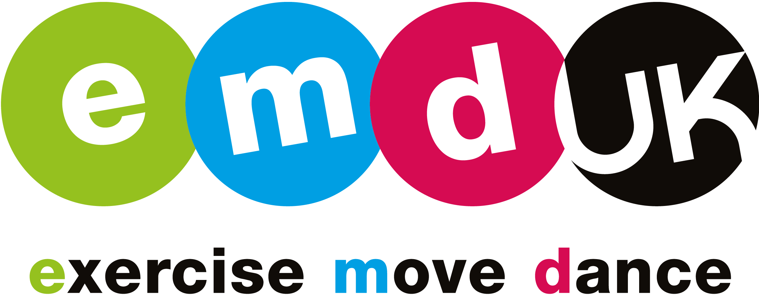
Posted: January 2018
Closing date: 18 February 2018
Independent Board Directors
As the national governing body for group exercise, EMD UK (Exercise, Move, Dance UK) is seeking independent directors for its board. These non-executive positions will oversee the strategic direction and growth of one of the countries most popular governing bodies. Group exercise has few barriers to participation and, therefore, creates vast opportunities for individuals to fulfil their physical activity, health and well-being goals. As a result, group exercise has the potential to be the nation’s favourite sporting / physical activity - can you help EMD UK take the steps to get there?
About EMD UK

Group exercise is consistently ranked in the country’s top five most popular sports / activities and whilst it has a strong appeal to male and females there is a higher percentage of women taking part. EMD UK is the principal organisation governing group exercise with a responsibility to promote its benefits, support the teachers and organisations working in the sector and to fulfil the Sport England criteria around maintaining participation. Unlike most governing bodies of sport which only cover one activity, EMD UK has a wide scope in its remit and covers a broad variety of styles to suit each demographic segment. At one end of the spectrum, and thanks to Strictly Come Dancing, there is the cultural phenomenon of dance fitness which leads into activities such as Spinning and BodyPump and out to Yoga and Pilates at the other end of the spectrum. Established in 2006, EMD UK is endorsed and funded by a variety of partners with a major investment of £2 million from Sport England over the 2013-17 period. Due to its strong governance and the recognition of the good work that has been achieved to date, Sport England have extended their funding through to 2019 and are showing increasing interest in EMD UK as a way of keeping the nation active. EMD UK, however don’t want to rely solely on funding and are developing their own revenue generating opportunities to help underpin the great work that they do and see a strong, vibrant board as part of this drive.

Through its work, EMD UK are becoming the expert authority and thought-leaders in the sector. Their mission is ‘To increase participation in group exercise by supporting teachers and organisations to deliver excellence”. They do this by providing:
- Membership - individual and organisational
- Insight and research
- Training and development through our Academy
- Participation initiatives with our campaign linking to national activity drivers such as Sport England’s This Girl Can and BBC’s Strictly Come Dancing’s ‘Keep Dancing’.
- Promoting the benefits of group exercise through media partners
The Board
Although EMD UK is the national governing body, its governance is as a not-for-profit company limited by guarantee. The EMD UK board is comprised of directors who abide by the Nolan principles whilst offering a mix of skills and experience that help the organisation meet its strategic aims.
The Board meets four times each year, normally on a Thursday or Friday, in London from 11.00 am until 4.00 pm. Meetings are usually held at the offices of the Sport and Recreational Alliance offices in Victoria, London.
The Role
Directors can serve up to two four-year terms. It is anticipated that the time commitment is up to one day per month after the induction period. This includes attendance at up to four Board meetings a year.
Expenses will be paid in accordance with EMD UKs expense policy.
The duties of a director include:
- To ensure that EMD UK complies with its Articles of Association, company law and any other relevant legislation or regulations.
- To contribute actively to the role of the Board in giving firm strategic direction to the organisation, setting overall policy, defining goals and setting targets and evaluating performance against agreed targets.
- To ensure the effective and efficient administration of EMD UK.
- To ensure the financial stability of EMD UK through commercial income
- To appoint the chief executive officer(s) and monitor their performance.
- In addition to the above statutory duties, each director should use any specific skills, knowledge or experience they have to help the board reach sound decisions. This may involve scrutinising board papers, leading discussions, focusing on key issues, providing advice and guidance on new initiatives or on other issues in which the Director has special expertise.

Key Competencies:

- A high level of objectivity and independent judgement
- A high level of integrity and probity
- Ability to think and act strategically
- An understanding of financial management
- An ability to work in partnership
- A commitment to equity and equal opportunities
- Ability to communicate concisely and effectively
- An enthusiasm for group exercise

Skills and Experience:
EMD UK is seeking directors with experience in one or more of the following areas:
- Teaching / instructing group exercise
- Lobbying / Sector Influence
- Fundraising / Sponsorship
- HR / Organisation Development
- Marketing / Insight
- Legal
- IT

Please submit a CV and letter of application to ross@emduk.org
For an informal discussion on the post of EMD UK director, please contact Innes Milne (Chair) on 07785 114143 or Ross Perriam (Chief Executive) on 01403 266000.
Closing date for applications is midnight on Sunday, 18th February 2018.

