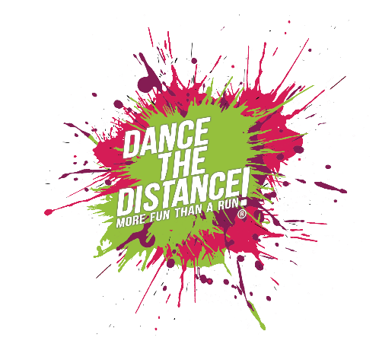

**Dance the Distance®**

**Licence Agreement**

This Licence Agreement (the Agreement) is made between The Exercise, Movement and Dance Partnership, trading as EMD UK and you (the Instructor) and becomes effective immediately upon purchase of the Dance the Distance® Instructor Pack.

EMD UK will design and provide all education and content deemed necessary for the delivery of Dance the Distance® (the Product).

EMD UK is the owner of the trademarks shown herein (the Marks) which are used on or in connection in any way, with the training, delivery or marketing of the Product.

The Instructor is licenced to deliver Dance the Distance® events using only the choreography and formats provided (the Services)

Dance the Distance® can only be delivered by licenced instructors who are members of EMD UK (annual membership is included when a licence pack is purchased). Instructors must abide by the terms and conditions of membership at all times.

All Dance the Distance® events must be registered with EMD UK and all participants must also be registered. Unregistered events will NOT be insured and will be considered in breach of the licence terms.

**Definitions**

**Licence** A non-exclusive, non-transferrable license (the Licence) to deliver the Product in accordance with the materials provided whether it be online, in the Instructor Pack or at any live training.

**License Period** The license shall be binding from the date of purchase for a period of 12 months

**License Fee** The annual payment required to be made by the instructor to EMD UK for the right of title ‘Dance the Distance® Instructor’ and to deliver Dance the Distance® Events.

**Instructor Pack** means, amongst other things, any and all material and instruction provided by EMD UK to the Instructor in whatever form it is delivered.

**Terms**

1. **Grant of Licence**

In consideration for the payment of the licence fee, EMD UK grants to the instructor a licence, without warranty, to deliver the Services and use the Marks provided. The Instructor accepts the licence and agrees to abide by its conditions during the license period. The instructor shall receive access to the online resource platform, including access to content, programme materials, and choreography.

1. **Copyright, Trademarks and Intellectual Property Rights**

All copyright, trademarks and intellectual property rights in or arising out of, or in connection with this Agreement are owned by EMD UK.

The instructor agrees to use the marks only as provided by EMD UK and not to alter in any way their design by proportion, shape, colour or otherwise, without the expressly written prior consent of EMD UK.

The instructor may use the Marks as provided on posters, flyers, electronic mail and printed promotional materials whose sole purpose is to promote the Product, and on no other promotional materials. All other production of articles displaying the Marks, whether for personal use or for sale to any third party, is strictly prohibited. The Instructor must not alter the Dance the Distance® name or create his/her own programme names.

**Domain Name**

The creation of any domain name which uses the “Dance the Distance®” title must have prior written approval from EMD UK. Use of the Mark is permitted for Facebook pages, twitter, Instagram and other social media accounts in line with the marketing guidelines provided.

**Merchandise**

The Instructor must not manufacture, create, offer for sale, sell or distribute any merchandise, including apparel, accessories, CDs, DVDs or promotional items, bearing the Dance the Distance® IP or any names, designs or logos similar to the Marks. The Instructor must not copy, duplicate, sell, distribute, upload, stream or otherwise disseminate any materials, provided by EMD UK.

1. **Cancellations and Termination**

**Termination by EMD UK**

EMD UK may immediately terminate this Agreement and Instructor’s membership at any time, with or without cause, by giving the Instructor written notice.

**Cancellation by Instructor**

The Instructor may cancel this Agreement at any time after the Initial Term subject to the terms, conditions and processes set forth by EMD UK. Memberships are strictly non-refundable after the 14-day cooling off period.

1. **Third-Party Infringement**

The Instructor must promptly notify EMD UK of any unauthorized use of the Dance the Distance® IP by a third party for which Instructor becomes aware. EMD UK has the sole right and discretion to take action, including bringing action and retaining the proceeds of any settlement or recovery in such action. The Instructor agrees to cooperate with EMD UK in enforcing and protecting the Dance the Distance® IP.

**5. Natures of Services**

Dance the Distance® events may not be safe or appropriate for everyone. Any information EMD UK may provide to the Instructor through training, in materials, or on online regarding health and fitness is intended solely as educational aids and are not substitutes for medical advice. The Instructor is encouraged to seek medical advice before providing the Services, or if the Instructor experiences any medical condition affecting their ability to provide the Services. The Instructor must ensure that he/she complies with all applicable laws, regulations and ordinances governing the instruction of children in the country, state and locality where the Product is delivered. EMD UK Safeguarding protocols must be followed at all times.

**Disclaime**r

EMD UK assume no responsibility for any consequence relating directly or indirectly from any action or inaction of the Instructor based on the information, services, or other material provided by EMD UK. While EMD UK strives to provide complete, up-to-date and accurate information on its website(s) and in other materials, EMD UK will not be responsible or liable for, any damage or loss related to the accuracy, completeness, or timeliness of such information. For any accident, injury, illness, death, loss, damage to person or property, or other consequences suffered by any person arising or resulting from the Instructor’s provision of the Services. If the Instructor is injured providing the Services, the Instructor assumes any financial obligations for any medical costs they may incur. EMD UK assumes no responsibility for any medical expenses, injury, or damages suffered by Instructor, or Instructor’s participants, in connection with the provision of the Services.

Dance the Distance has been developed and extensively tested with activity trackers to match 5km as closely as possible. Due to the nature of the activity and the variance in individual step length, participants may cover more or less than 5km on the day. It is an approximate equivalent only to covering a distance of 5km.