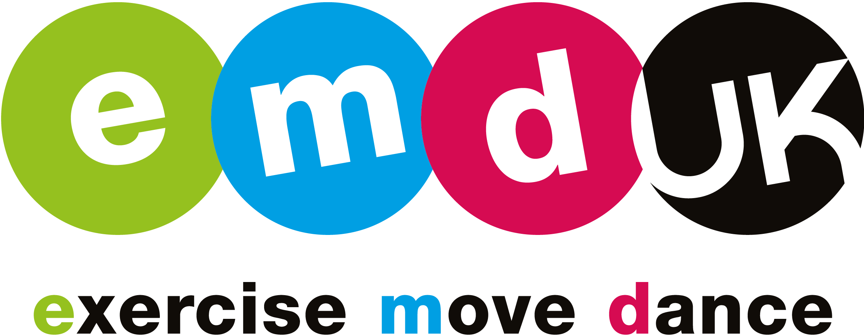
Chief Executive Officer

Reports to EMD UK non-executive Chair

Job based at EMD UK offices in Horsham

Salary: Competitive
Posted: April 24th 2019
Closing date: May 28th 2019

As the national governing body for group exercise, EMD UK (Exercise, Move, Dance UK) is seeking a Chief Executive Officer to lead the organisation. This exciting position will oversee the strategic direction and growth of one of the countries most popular governing bodies. Group exercise has few barriers to participation and, therefore, creates vast opportunities for individuals to fulfil their physical activity, health and well-being goals. As a result, group exercise has the potential to be the nation’s number one sporting / physical activity - can you help EMD UK take the steps to get it there?
About EMD UK

Group exercise is consistently ranked as one of the country’s most popular sports / activities and whilst it has a strong appeal to male and females there is a higher percentage of women taking part. EMD UK is the principal organisation governing group exercise with a responsibility to promote its benefits, support the teachers and organisations working in the sector and to fulfil the Sport England criteria around maintaining participation. Unlike most governing bodies of sport which only cover one activity, EMD UK has a wide scope in its remit and covers a broad variety of styles to suit each demographic segment. At one end of the spectrum there is the cultural phenomenon of dance fitness which leads into activities such as Spinning and BodyPump and out to Yoga and Pilates at the other end of the spectrum. Established in 2006, EMD UK is endorsed and funded by a variety of partners with a track record of major investment from Sport England. Due to its strong governance and the recognition of the good work that has been achieved to date, Sport England have extended their funding through to 2021 and are showing increasing interest in EMD UK as a way of keeping the nation active. EMD UK, however don’t want to rely solely on funding and are developing their own revenue generating opportunities to help underpin the great work that they do and see a strong, vibrant organisation as part of this drive.
Through its work, EMD UK are becoming the expert authority and thought-leaders in the sector. Their mission is ‘To increase participation in group exercise by supporting teachers and organisations to deliver excellence”. They do this by providing:
- Membership - individual and organisational
- Insight and research
- Training and development through our Academy
- Participation initiatives with our campaign linking to national activity drivers such as Sport England’s This Girl Can and BBC’s Strictly Come Dancing’s ‘Keep Dancing’.
- Promoting the benefits of group exercise through media partners
Although EMD UK is the national governing body, its governance is as a not-for-profit company limited by guarantee. The EMD UK board is comprised of directors who abide by the Nolan principles whilst offering a mix of skills and experience that help the organisation meet its strategic aims.
The CEO is responsible to the Board of Directors for the effective planning, performance, direction and leadership of EMD UK.
The Role
Key Accountabilities
- Create a strong sense of purpose and direction through visionary and inspirational leadership;
- Raise the profile and status of EMD UK as the “voice” of group exercise within the sector;
- Inspire staff and volunteers to maximise organisational results through people;
- Optimise revenue (grant funding and commercial) opportunities that align to the mission and vision of the organisation and deliver the strategic aims;
- Lead the development and execution of EMD UK’s Strategic Action Plan, in compliance with the vision, statutory requirements and best practice guidelines;
- Represent EMD UK effectively to all internal and external stakeholders, ensuring the integrity and protection of the organisation and its values, brand image and policies and strategies;
- Build upon the strong relationship with Sport England and other strategic stakeholders;
- In conjunction with the Board, set budgets and manage them effectively and efficiently;
- Lead, manage and develop the senior management team, building a high-performance culture that improves organisational performance and progresses the ambition to create sustainable development of the organisation.

Key Competencies:

- Strong leadership ability;
- Strong commercial business acumen and an appreciation of working within the constraints of a representative not-for-profit organisation;
- A high level of objectivity and independent judgement, taking accurate and decisive action;
- Ability to think and act strategically and to manage change;
- Highly developed financial acumen, with experience of interpreting financial information, preparing budgets, funding proposals and /or commercial tenders;
- An ability to work in partnership and to nurture strategic relationships; a natural networker;
- Experience of and commitment to developing staff;
- A commitment to equity and equal opportunities;
- Ability to communicate concisely and effectively;
- An enthusiasm for group exercise.

Skills and Experience:
EMD UK is seeking a CEO with the following:-
- A proven track record in management, leadership and relationship building;
- Experience of working at Executive / Board level;
- Educated to degree level or equivalent;
- Strong partnership working abilities, specifically in negotiation and influencing within a high performing environment;
- Highly developed strategic planning, problem solving and decision-making skills;
- Experience of dealing with the media and the presentation of information to external and internal audiences;
- Demonstrated success as an executive leader within a sport, fitness, physical activity or dance environment;
- Highly developed IT and administrative skills; appreciation of the potential impact of technology / social media on an organisation;
- Prepared to work unsocial hours and to travel within the UK as required;
- Full UK driving licence.
How to Apply
EMD UK is an equal opportunities employer and would welcome applications from a diverse range of candidates, regardless of age, gender, ethnicity, sexual orientation, faith or disability.
Please submit by email to yvonne@emduk.org
- Letter of application that highlights your motivation for the post and relevant experience
- Curriculum vitae
- Details of current remuneration
- Names and contact details for two professional referees together with a brief statement of the capacity and period of time they have known you (referees will not be contacted without your prior consent)
- Completed Diversity Monitoring form (available at www.emduk.org)
For an informal discussion on the post of EMD UK CEO, please contact Nigel Wallace (Chair) on 07717 745771; Julie Evans (Board Director) on 07887 545276, Ross Perriam (CEO-current) on 07715 081638
Closing date for applications is May 28th 2019
Interviews are currently scheduled to take place in central London on June 26th 2019.
Further information on EMD UK can be found at www.emduk.org

