

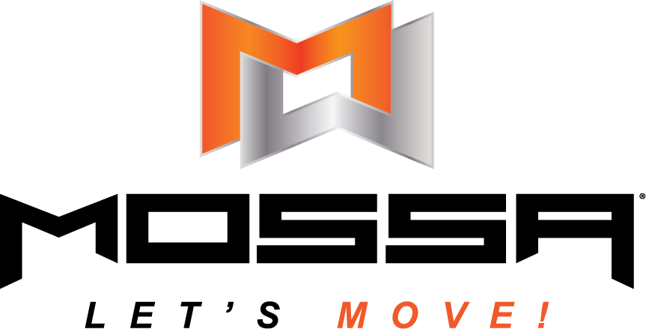

EMD UK SCOPE OF PRACTICE
Core Group Exercise Instructor
MOSSA™

SECOND EDITION: | 5th June 2025
REVIEW DATE: | 5th June 2026

SCOPE OF PRACTICE: Core Group Exercise Instructor

Contents

1. Scope of the MOSSA™ Instructor
2. EMD UK professional recognition membership eligibility
3. EMD UK Membership Eligibility ………………………………………………………...

ABOUT THIS SCOPE OF PRACTICE
This document is an EMD UK Scope of Practice overview for professional recognition membership of the national governing body for group exercise. Determining what is and is not part of your scope of practice will be for you to decide using your professional judgement. When deciding whether a particular activity falls within your scope of practice, or when moving into a new scope of practice, you will need to consider whether the training and support you have received adequately equips you to perform the activity safely and effectively. This document defines the scope of practice, training, and skills of a MOSSA™ Instructor and the general scope of practice to teach this activity safely and effectively.

You may find it helpful to speak to the professional recognition membership team who may be able to offer further advice in this area.

Published by:  EMDP Ltd T/A EMD UK  National Governing Body for Group Exercise  Publication date: 5th June 2025  First edition: V2.0  © EMDP Ltd |   SYSTEM PARTNER

1. Overview

SCOPE OF PRACTICE: MOSSA ™
Scope of practice refers to those activities that a group exercise teacher/instructor is licensed to practice and is permitted to teach in a group exercise setting. An individual teacher/instructor must decide their own scope of practice and be able to evidence this through their qualifications, skills, experience, or knowledge. Your scope of practice is the limit of your knowledge, skills and experience and you must ensure that you work within your scope of practice. Your scope of practice is likely to change over time as your knowledge, skills and experience develop. The health and safety of participants is threatened when professionals, are permitted to perform services that are beyond the boundaries of what they have been educated and trained to do.
This scope of practice overview sets clear expectations of our members’ knowledge, skills, and abilities when they start practising MOSSA™ classes.
As you progress in your career, you may enter more specialist practitioner roles where you are no longer meeting all the standards of proficiency. Your scope of practice will develop with you and may become narrower in scope.
The MOSSA ™ Instructor sits in the scope of practice of the Core Group Exercise Instructor as part of the exercise and fitness profession.
The agreed industry prerequisite to become a MOSSA™ instructor is to have achieved a full level 2 awarding organisation endorsed level 2 fitness instructor qualification, equivalent or higher or an approved ‘bridging qualification’ that meets the professional standards. Individuals who achieve this will be deemed to meet the requirements for professional recognition membership within the scope of practice of MOSSA ™. If transitioning from a similar approved pre choreographed programme, e.g., Les Mills, with no level 2 fitness instructor qualification, equivalent or higher, then an approved ‘bridging qualification’ must be taken.
MOSSA™ certification is valid annually if the instructor can also demonstrate three update points gained from MOSSA™. To retain professional recognition for scope of practice as a MOSSA™ instructor you must meet the update requirements set by MOSSA™ and 10 hours of ‘Professional Development’ per year. The MOSSA education on the quarterly releases may be included as part of the 10 hours of professional development per year. These educations will be evidenced annually by quiz questions created by Fitpro.

Agreed scope of practice educational products logo
Educational products that meet the requirements of EMD UK’s scope of practice may display this official EMD UK scope of practice logo.

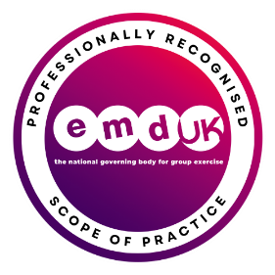

2. Scope of a MOSSA ™ Fitness Instructor
MOSSA instructors are fitness professionals who teach, lead, and motivate groups of individuals through intentionally designed Pre choreographed classes.
- They are responsible for engaging, facilitating, supporting, educating, and instructing safe and effective classes.
- Connect with participants to ensure a motivating, positive group exercise experience.

- Ensure participants are screened prior to participation and referred to appropriate health or exercise professionals if necessary.

- Provide safe, effective, inclusive MOSSA group exercise programmes providing supervision modifications and alternative movements to accommodate a range of abilities and experience to ensure classes remain engaging, varied, and progressive to clients’ needs and goals.

- Understand their responsibility for health and safety relating to the environment, whilst using bodyweight progressions and equipment and the class participants

- Encourage the participants to progress and ensure the recommended shelf-life guidelines are followed to maximise the programme quarterly workout periodised target is achieved.

- To teach MOSSA workouts to groups maintaining the brand architecture of the relevant programme.

- To provide guidance on the utilisation of relevant equipment in programmes where it is a necessary tool for the workout.

- Understand the power of the branding of MOSSA and the programme in which they are certified.

MOSSA instructors may teach in-person classes and online classes and the latter may require a
further set of skills and knowledge.

3. EMD UK membership eligibility
Instructors who meet the requirement within this scope of practice will meet the requirements to be a professionally recognised member of the National Governing Body for Group Exercise to work within the identified scope of practice.
They will:
UNDERSTAND:
- How to work with a Group of healthy clients with unique needs, in different types of environments, aged between 15 and 65 or above 65 without any long-term conditions.

- Teaching group exercise to adults with a long-term health condition of any age including above the age of 65 may, require further skills and training. If adapting exercise programmes/classes/sessions requires the teacher to apply specialist adaptations related to a long-term condition, then further training relevant to the required specialist professionals’ standards will be required.

- Working outside the scope of practice age and target group range may require further skills and training if adaptations to work with clients falls outside what would be considered normal fitness related adaptations, modifications, or progressions, or clients present with long term-controlled conditions.

HAVE DEMONSTRATED:
- Competence of working with a group of clients, in a single environment relevant to MOSSA ™
Additional specialist training to meet further scopes of practice for varied populations, environment or technical ability can be added to this scope of practice to widen the scope of the role and enable an individual to show their expertise in additional populations, in different environments and with technical specialisms.

Examples of specialisms that may be added:
- Working with clients with long term-controlled conditions.
- Working with older adults.
- Working with ante and post-natal clients.
- Designing exercise programmes for Disabled Clients

